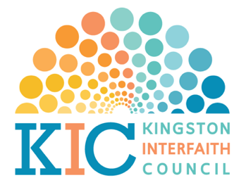
LINKS TO LOCAL GOVERNING OFFICIALS
In New York State, Ulster County & Kingston

Ulster County COVID-19 Hotline: 845-443-8888

Governor – Andrew M. Cuomo
The Honorable Andrew M. Cuomo
Governor of New York State
NYS State Capitol Building
Albany, NY 12224
Website: https://www.governor.ny.gov
Phone:1-518-474-8390

Ulster County Executive – Patrick Ryan
Patrick K. Ryan, Ulster County Executive
Office of Ulster County Executive
County Office Building, 6th Floor
244 Fair Street
Kingston, New York 12401
Office: (845) 340-3800
Website: https://ulstercountyny.gov/executive/office-ulster-county-executive
Email: exec@co.ulster.ny.us

Mayor – Steven T. Noble
Steven T. Noble, Mayor
City of Kingston
420 Broadway
Kingston, New York 12401
Office: (845) 334-3902
Website: https://kingston-ny.gov/
Email: mayor@kingston-ny.gov

Ulster County Sheriff – Juan Figueroa
Sheriff Juan Figueora
Ulster County Law Enforcement Center
380 Boulevard
Kingston, NY 12401
Office: (845) 340-3590
Cell: 845-549-5616
Website: https://ulstercountyny.gov/sheriff
Email: sheriff@co.ulster.ny.us

LINKS TO FEDERAL OFFICIALS

President of the United States
President Donald Trump
The White House
1600 Pennsylvania Avenue NW
Washington, DC 20500
Website: https://www.whitehouse.gov/

U.S. Senator - Gillibrand
Senator Kirsten Gillibrand
Leo W. O’Brien Federal Office Building, Room 821
11A Clinton Avenue,
Albany, NY 12207
Tel. (518) 431-0120
Fax (518) 431-0128

D.C. Office:
Senator Kirsten Gillibrand
478 Russell
Washington, DC 20510
Tel. (202) 224-4451
Fax (202) 228-4977

U.S. Senator – Schumer
Senator Charles E. Schumer
Leo O'Brien Building, Room 420
Albany, NY 12207
Phone: (518) 431-4070
Fax: (518) 431-4076

DC Office:
Senator Charles E. Schumer
322 Hart Senate Office Building
Washington, D.C. 20510
Phone: (202) 224-6542
Fax: (202) 228-3027

Congressman – Delgado
Antonio Delgado, Congressman
United States Congress
265 Clinton Avenue
Kingston, New York 12401
Office: (845) 443-2930 or (202) 225-5614
Website: https://delgado.house.gov/

